ADM01 - AI LAB 2
Experiment 5: Solving the 8-Queens Problem Using Backtracking
AIM: To find the collision-free placement of components on a grid.
QUESTION:
An automated placement system must position eight components on an 8 × 8 grid such that no two components interfere with one another. Model this as the 8-Queens problem, where each queen represents a component and can attack another queen along the same row, column, or diagonal.
Develop a Python program using the backtracking algorithm to find a valid arrangement of eight queens on the chessboard.
The program must:
- Represent the chessboard as an 8 × 8 grid and track the positions of the queens.
- Place one queen at a time while ensuring that no two queens share the same row, column, or diagonal.
- Use recursive backtracking to undo an invalid placement and explore alternative positions.
- Display the final chessboard arrangement and the positions of all eight queens.
- Report the number of placement attempts and explain how constraint checking and backtracking help find a valid solution.
CODE:
N = 8
board = [-1] * N
attempts = 0

def is_safe(row, col):
for r in range(row):
if board[r] == col:
return False

if abs(board[r] - col) == abs(r - row):
return False

return True

def solve(row):
global attempts

if row == N:
return True

for col in range(N):
attempts += 1

if is_safe(row, col):
board[row] = col

if solve(row + 1):
return True

# Backtrack: remove the queen
board[row] = -1

return False

if solve(0):
print("Solution found!")
print("\nChessboard:")

for row in range(N):
for col in range(N):
if board[row] == col:
print(" Q ", end="")
else:
print(" . ", end="")
print()

print("\nQueen positions (Row, Column):")
for row in range(N):
print(f"Queen {row + 1}: ({row + 1}, {board[row] + 1})")

print("\nTotal placement attempts:", attempts)
else:
print("No solution exists.")

OUTPUT:
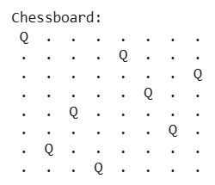
Queen positions (Row, Column):
Queen 1: (1, 1)
Queen 2: (2, 5)
Queen 3: (3, 8)
Queen 4: (4, 6)
Queen 5: (5, 3)
Queen 6: (6, 7)
Queen 7: (7, 2)
Queen 8: (8, 4)
Total placement attempts: 876

Experiment 6: Solving the Map Colouring Problem Using CSP
AIM: To make frequency allocation for neighbouring cellular network regions.
QUESTION:
A telecommunications network is divided into interconnected regions. To reduce interference, neighbouring regions must be assigned different frequency bands. Model the network as a Constraint Satisfaction Problem (CSP), where each region is a variable, the available frequency bands form its domain, and neighbouring regions must receive different assignments.
Develop a Python program to solve the map-colouring problem using CSP techniques.
The program must:
- Represent each region as a variable and define its available colours as a domain.
- Specify adjacency constraints requiring neighbouring regions to have different colours.
- Use backtracking search to find a valid colour assignment.
- Display the final map-colouring assignment and verify that all adjacency constraints are satisfied.
- Report the number of assignments attempted and explain how CSP variables, domains, and constraints guide the search.
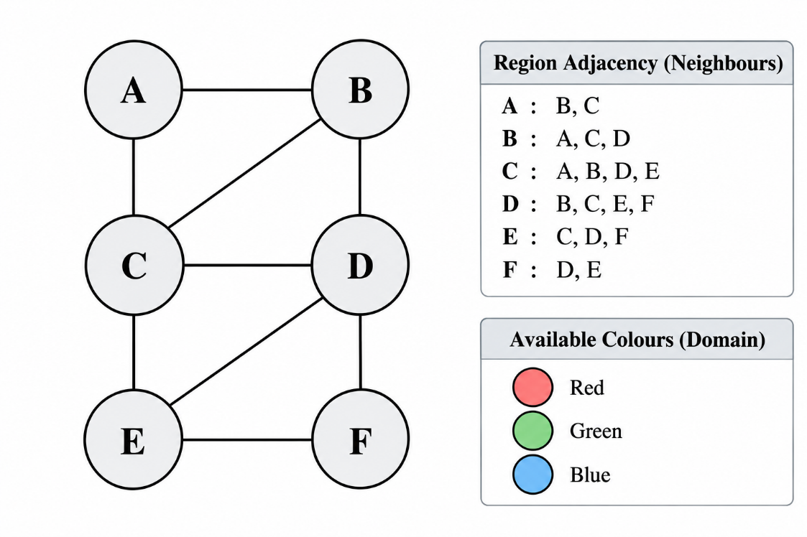

CODE:
# Map Colouring using CSP and Backtracking
regions = ['A', 'B', 'C', 'D', 'E', 'F']
colours = ['Red', 'Green', 'Blue']

adjacency = {
'A': ['B', 'C'],
'B': ['A', 'C', 'D'],
'C': ['A', 'B', 'D', 'E'],
'D': ['B', 'C', 'E', 'F'],
'E': ['C', 'D', 'F'],
'F': ['D', 'E']
}
assignment = {}
attempts = 0

def is_safe(region, colour):
for neighbour in adjacency[region]:
if assignment.get(neighbour) == colour:
return False
return True

def solve(index):
global attempts

if index == len(regions):
return True

region = regions[index]

for colour in colours:
attempts += 1

if is_safe(region, colour):
assignment[region] = colour

if solve(index + 1):
return True

# Backtrack
del assignment[region]

return False

if solve(0):
print("Valid Colour Assignment:\n")

for region in regions:
print(region, ":", assignment[region])

print("\nConstraint Verification:")

valid = True
for region in regions:
for neighbour in adjacency[region]:
if assignment[region] == assignment[neighbour]:
print("Conflict:", region, neighbour)
valid = False

if valid:
print("All adjacency constraints satisfied.")

print("Total assignment attempts:", attempts)

else:
print("No valid colouring exists.")

OUTPUT:
Valid Colour Assignment:
A : Red
B : Green
C : Blue
D : Red
E : Green
F : Blue
Constraint Verification:
All adjacency constraints satisfied.
Total assignment attempts: 12

Experiment 7 - Implementing the Minimax Algorithm
AIM: To demonstrate decision-making in a two-player strategy game.
QUESTION:
A game-playing AI must select its best move in a two-player game where one player tries to maximize the score while the opponent tries to minimize it.
Develop a Python program to implement the Minimax algorithm for a game represented as a binary game tree. The program must:
- Represent the game tree with terminal utility values.
- Treat the AI as the maximizing player and the opponent as the minimizing player.
- Recursively evaluate the game tree using the Minimax algorithm.
- Display the evaluated values and the best move selected by the AI.
- Explain how the algorithm assumes that both players choose optimal moves.

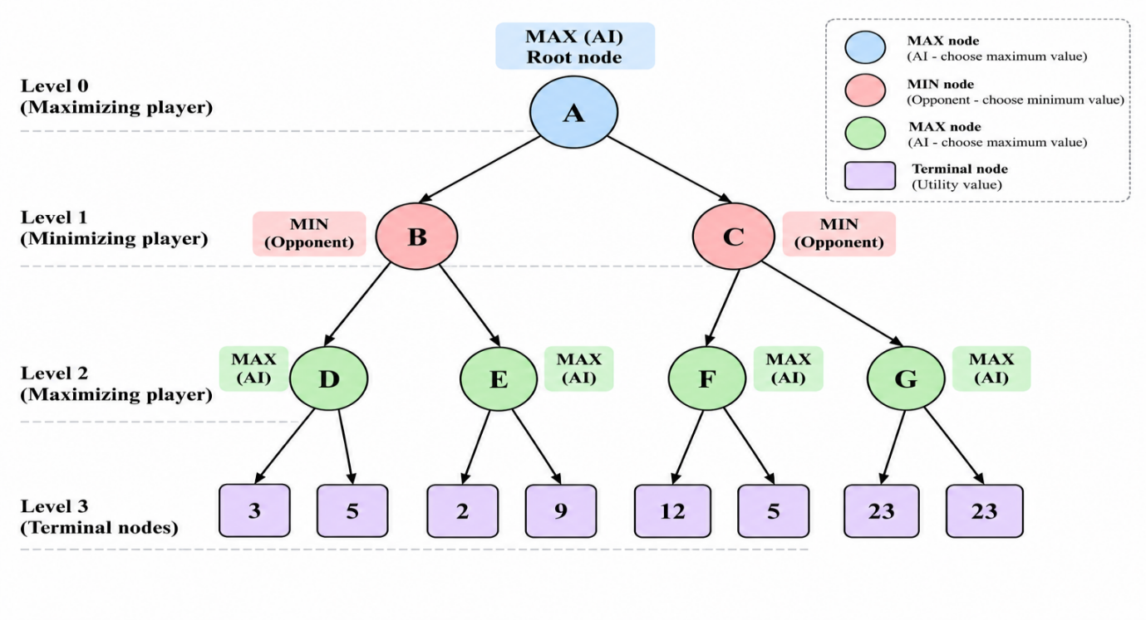
CODE:
# Minimax Algorithm
tree = {
'A': ['B', 'C'],
'B': ['D', 'E'],
'C': ['F', 'G'],
'D': [3, 5],
'E': [2, 9],
'F': [12, 5],
'G': [23, 23]
}
values = {}
def minimax(node, maximizing):
if isinstance(tree[node][0], int):
if maximizing:
values[node] = max(tree[node])
else:
values[node] = min(tree[node])
return values[node]

child_values = [
minimax(child, not maximizing)
for child in tree[node]
]
if maximizing:
values[node] = max(child_values)
else:
values[node] = min(child_values)

return values[node]
result = minimax('A', True)
print("Evaluated Node Values:")
for node in sorted(values):
print(node, ":", values[node])

best_move = max(tree['A'], key=lambda child: values[child])
print("\nBest Move for AI:", best_move)
print("Maximum Utility Value:", result)

OUTPUT:
Evaluated Node Values:
A : 12
B : 5
C : 12
D : 5
E : 9
F : 12
G : 23

Best Move for AI: C
Maximum Utility Value: 12

Experiment 8 - Implementing Alpha-Beta Pruning
AIM: To optimize decision-making in a two-player strategy game.
QUESTION:
A chess-playing AI evaluates possible moves by exploring a game tree. Since evaluating every possible move is computationally expensive, the AI uses Alpha-Beta Pruning to eliminate branches that cannot influence the final decision.
Develop a Python program to implement the Alpha-Beta Pruning algorithm for a chess-inspired game tree with multiple possible moves and terminal utility values.
The program must:
- Represent the game tree with multiple candidate moves and terminal utility values.
- Implement Alpha-Beta Pruning using alpha and beta bounds.
- Identify and skip branches that cannot affect the final decision.
- Display the selected move, its utility value, the number of nodes evaluated, and the number of branches pruned.
- Explain how Alpha-Beta Pruning reduces the search effort while preserving the optimal decision.
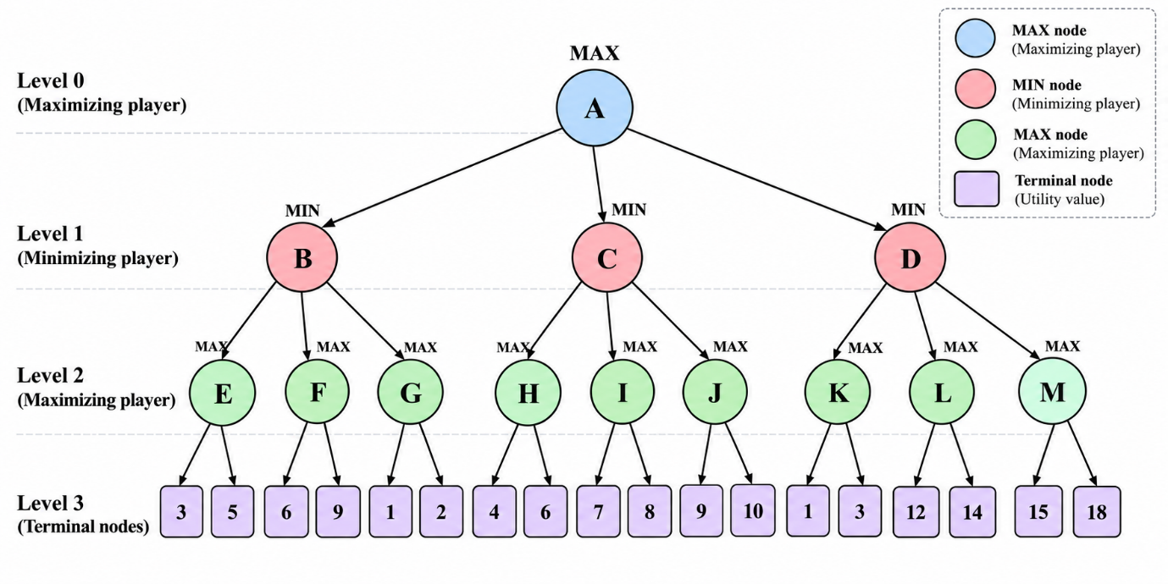

CODE:
# Alpha-Beta Pruning
tree = {
'A': ['B', 'C', 'D'],
'B': ['E', 'F', 'G'],
'C': ['H', 'I', 'J'],
'D': ['K', 'L', 'M'],
'E': [3, 5],
'F': [6, 9],
'G': [1, 2],
'H': [4, 6],
'I': [7, 8],
'J': [9, 10],
'K': [1, 3],
'L': [12, 14],
'M': [15, 18]
}

values = {}
nodes_evaluated = 0
branches_pruned = 0

def minimax(node, alpha, beta, maximizing):
global nodes_evaluated, branches_pruned

children = tree[node]

# Terminal node: evaluate utility values
if isinstance(children[0], int):
return max(children) if maximizing else min(children)

if maximizing:
best = float('-inf')

for i, child in enumerate(children):
value = minimax(child, alpha, beta, False)
best = max(best, value)
alpha = max(alpha, best)

if alpha >= beta:
branches_pruned += len(children) - i - 1
break

else:
best = float('inf')

for i, child in enumerate(children):
value = minimax(child, alpha, beta, True)
best = min(best, value)
beta = min(beta, best)

if alpha >= beta:
branches_pruned += len(children) - i - 1
break

values[node] = best
return best

def count_terminal_nodes(node):
global nodes_evaluated

children = tree[node]

if isinstance(children[0], int):
for value in children:
nodes_evaluated += 1
return

for child in children:
count_terminal_nodes(child)

# Run Alpha-Beta Pruning
result = minimax('A', float('-inf'), float('inf'), True)

# Find values of the root's children for the selected move
print("Best Move Values:")

for child in tree['A']:
values[child] = minimax(
child, float('-inf'), float('inf'), False
)
print(child, ":", values[child])

# Count actual terminal evaluations during a single search
nodes_evaluated = 0
branches_pruned = 0

def alpha_beta(node, alpha, beta, maximizing):
global nodes_evaluated, branches_pruned

children = tree[node]

if isinstance(children[0], int):
best = float('-inf') if maximizing else float('inf')

for i, value in enumerate(children):
nodes_evaluated += 1

if maximizing:
best = max(best, value)
alpha = max(alpha, best)
else:
best = min(best, value)
beta = min(beta, best)

if alpha >= beta:
branches_pruned += len(children) - i - 1
break

return best

best = float('-inf') if maximizing else float('inf')

for i, child in enumerate(children):
value = alpha_beta(child, alpha, beta, not maximizing)

if maximizing:
best = max(best, value)
alpha = max(alpha, best)
else:
best = min(best, value)
beta = min(beta, best)

if alpha >= beta:
branches_pruned += len(children) - i - 1
break

return best

values.clear()
best_value = alpha_beta('A', float('-inf'), float('inf'), True)

# Determine the best move from the minimax values
for child in tree['A']:
values[child] = minimax(
child, float('-inf'), float('inf'), False
)

best_move = max(tree['A'], key=lambda x: values[x])

print("\nBest Move for AI:", best_move)
print("Maximum Utility Value:", best_value)
print("Terminal Nodes Evaluated:", nodes_evaluated)
print("Branches Pruned:", branches_pruned)

OUTPUT:
Best Move Values:
B : 2
C : 6
D : 3
Best Move for AI: C
Maximum Utility Value: 6
Terminal Nodes Evaluated: 11
Branches Pruned: 5

